Report
Vishing & Smishing Simulation Scripts

Day 4

Name : Amber Waseem

Task#04

Intern: Amber Waseem
Program: Sqrock IT Solution Alpha 2 Internship, Cybersecurity Track

OBJECTIVE
Model realistic voice-phishing (vishing) and SMS-phishing (smishing) social-engineering scripts for internal security awareness training.
Build a Python-based generator that produces training call/text scripts, each tagged with red-flag callouts so trainees learn to recognize manipulation tactics rather than fall for them.
THEORY
Vishing (voice phishing): attacker calls and impersonates a trusted party IT support, a bank, or a government agency to extract credentials or sensitive data.
Smishing (SMS phishing): attacker sends a text message with a spoofed alert and a malicious/short link designed to prompt an urgent click.
Psychological triggers exploited: authority, urgency, fear, scarcity, and liking. Combining several of these raises click/compliance rates significantly.
APPROACH / IMPLEMENTATION
generate_vishing_script(): builds a call script per scenario (IT Support, Bank Fraud Alert) using randomized openers, hooks, and urgency lines, plus a fixed red-flag block for that scenario type.
generate_smishing_script(): builds an SMS-based script with a randomized alert template, a simulated training link, and its own red-flag block.
TRIGGER_LIBRARY + analyze_triggers() maps each scenario to the psychological triggers it relies on (authority, urgency, fear, scarcity, liking) with a one-line explanation of each.
Randomization (random.choice) across openers/hooks/urgency lines means each run produces slightly different wording for the same scenario useful for varied, non-repetitive training material.
All output is explicitly labeled "TRAINING USE ONLY" and every script ends with a red-flags section the deliverable teaches recognition, it does not produce deployable phishing content.

DELIVERABLE 3 SCENARIOS GENERATED
IT Support Pretext (vishing) Sqrock IT, pretext: Password Reset. Triggers: authority, urgency, fear.
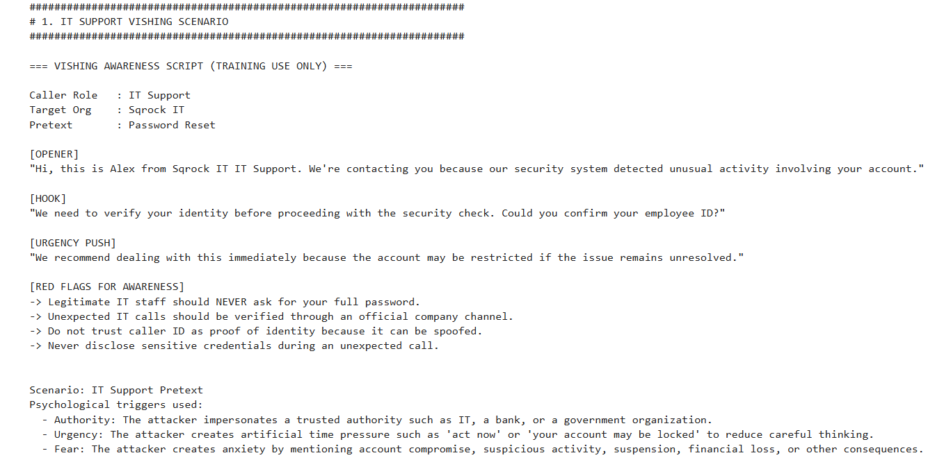
Bank Fraud Alert Pretext (vishing) Meridian National Bank, Fraud Prevention Dept, pretext: Suspicious Transaction Alert. Triggers: authority, fear, urgency.
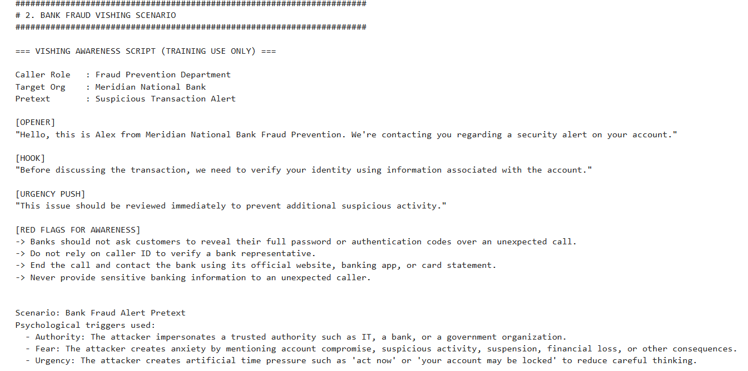
Government Tax Refund Pretext (smishing) National Revenue Service, pretext: tax refund eligibility, simulated training link. Triggers: authority, urgency, fear.
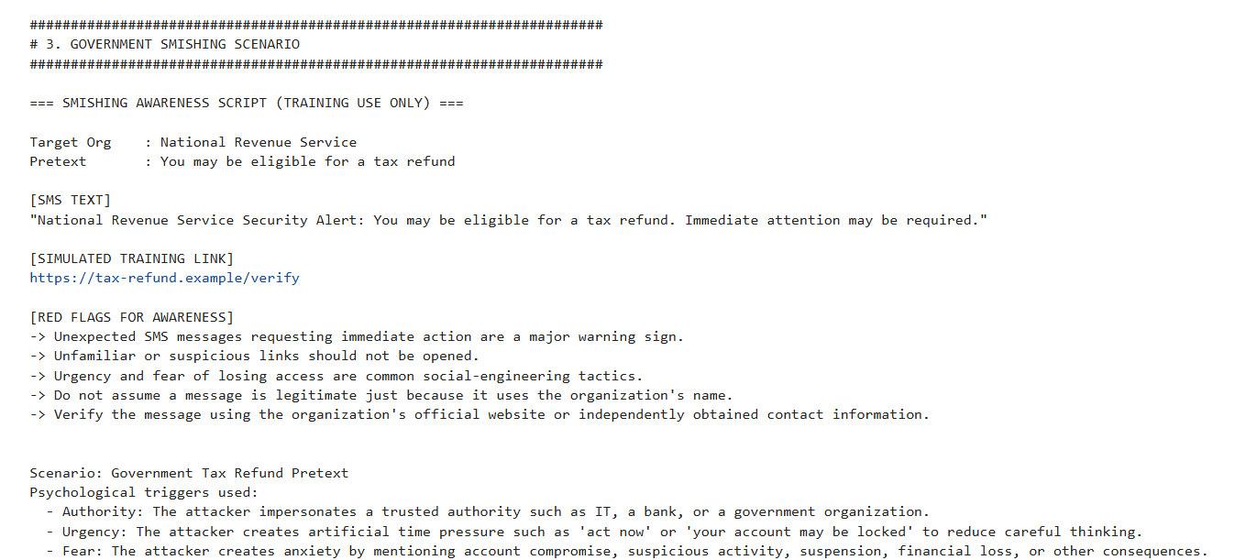
KEY TAKEAWAYS
Authority + urgency + fear is the most common combination across all three scenarios this is the pattern trainees should learn to flag first.
No legitimate IT, bank, or government contact will ask for a full password, OTP, or authentication code over an unsolicited call or text.
The safest response to any unexpected urgent request is to hang up / not click, then independently verify through an officially published contact channel.
Tools: Python (stdlib random)

